Hardware

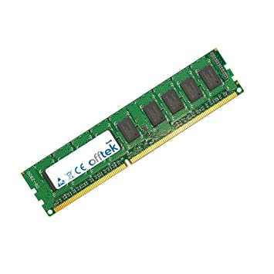RAM

One hardware that is used in an interactive multimedia product is a RAM (Random Access Memory). “This is a type of computer data storage. A RAM device makes it possible to access data in random order, which makes it very fast to find a specific piece of information. RAM devices are used in computer systems as the main memory. RAM is considered volatile memory, which means that the stored information is lost when there is no power. So, RAM is used by the central processing unit (CPU) when a computer is running to store information that it needs to be used very quickly, but it does not store any information permanently.” (<https://study.com/academy/lesson/what-is-random-access-memory-ram-definition-history-quiz.html>)

This is useful in an interactive multimedia product because it doesn’t take up too much space and the information is discarded when it is no longer needed which improves the computers performance as there is less space is needed. However, there are limitations to this because when the computer is turned off then the stored information is lost as it doesn’t store permanent information. The information that is stored is only temporary and it loads very quickly which is useful for multimedia products.

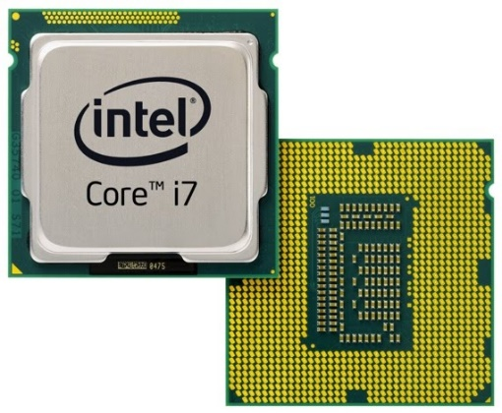CPU

The CPU (Central Processing Unit) is one of the most important parts of a computer and makes the computer run efficiently. “It’s distinctly separate from the memory, which is where information is stored, and the graphics card or graphics chip, which handles all rendering of video and 3D graphics to your monitor or screen.” (<https://www.digitaltrends.com/computing/what-is-a-cpu/>)

This is important in an interactive multimedia product because it is useful in storing information so things can be saved for example your scores in Hegarty Maths. It will also allow you to see your progress and see videos in good quality. Despite this it has limitations such as it is expensive so people may not be able to afford it. It also heats up quite quickly so you may need additional products such as a fan to cool it. Lastly, it needs to be updated often to the latest version because otherwise you cannot access some applications.

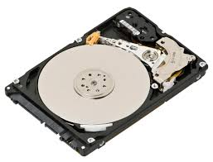Hard drive

A hard disk drive is used to read information in a computer. “It’s where all the data in your computer is stored for the long term — not just the things you save, but all the code required for your operating system, the framework browsers use to connect to the internet, drivers for your accessories, and everything else.” (<https://www.digitaltrends.com/computing/what-is-a-hard-drive-your-guide-to-computer-storage/>)

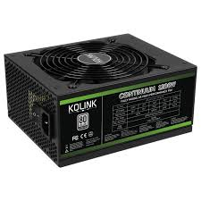This is useful in an interactive multimedia product because it has a lot of storage space so you can store a lot of information and save your progress. It is unlike RAM as the data stored is still saved even when the computer is switched off. The limitations of it are that it is very slow in revealing data which means it will take long to load up websites and applications. Also, “hard disks can crash which stop the computer from working, regular crashes can damage the surface of the disk which leads to loss of data in that sector and the disk is fixed inside the computer and cannot easily be transferred to another computer.” (<https://www.teachict.com/as_a2_ict_new/ocr/AS_G061/312_software_hardware/storage_devices/miniweb/pg5.htm>)

Power supply

The power supply is one of the most important parts of a computer because without it the main components will not be able to function properly or not at all. It also regulates the voltage to a safe level. “The power supply is the piece of hardware that converts the power provided from the outlet into useable power for the many parts inside the computer case.” (<https://www.lifewire.com/power-supply-unit-2618158>)

This is useful for the interactive multimedia product because if all the components work then a lot of information can be stored and loaded quickly. The limitations are that sometimes the power supply cannot regulate the voltage so it can get really high and therefore dangerous. This can also lead to work loss and the multimedia product may even stop working.

Video graphics card

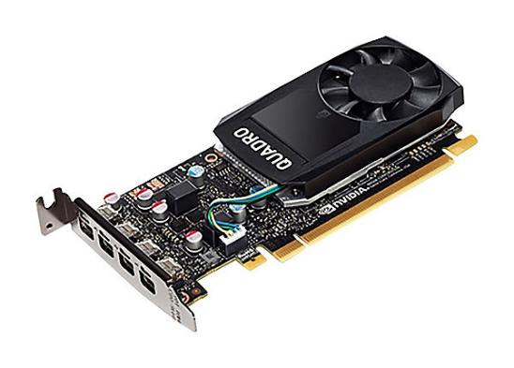“A video card is an expansion card that connects to a computer’s motherboard. It is used to create a picture on a display; without a video card, you would not be able to see this page… it processes images and video.” (<https://www.computerhope.com/jargon/v/video-card.htm>)

This is useful for an interactive multimedia product because without it, you will not be able to see pictures and video. If you can see them, it will be of very low quality and the graphics will be very poor so you will not be able to see them clearly and in detail. Also, it is good for some applications such as YouTube as there are millions of videos you can watch so good quality is needed to watch them in order for the target audience to be engaged. On the other hand, there are limitations as it can heat up quickly so additional products are needed such as a fan to cool it down to an appropriate level and it may not be supported on some devices such as a mobile phone.

Software

Adobe Flash Player

“Adobe Flash Player is computer software for using content created on the Adobe Flash platform, including viewing multimedia contents, executing rich Internet applications, and streaming audio and video. Flash Player can run from a web browser as a browser plug-in or on supported mobile devices.” (<https://en.wikipedia.org/wiki/Adobe_Flash_Player>)

This is useful in an interactive multimedia product because with this you can view videos and play audio so you can learn more about the multimedia product and see the content. It is further supported on many devices, even a mobile phone so it can be accessed through a wide range. There are limitations however because you need to download a plugin to access it, some mobiles can’t read flash which affects them accessing the multimedia product on their phones and a longer loading time, so the user has to wait a long time until the pages load up.

Java

Java is a programming device and without it, many applications and websites will not work unless you have it installed. “The latest Java version contains important enhancements to improve performance, stability and security of the Java applications that run on your machine. Installing this free update will ensure that your Java applications continue to run safely and efficiently.” (<https://java.com/en/download/faq/whatis_java.xml>)

This is useful in an interactive multimedia product because they need to be run safely and efficiently so that there are no unexpected crashes which will cause it to stop working and not be useful any more. It also will improve performance so everything will be faster to load. There are limitations to this as it is sometimes very slow which will result in pages, websites and applications taking long to load and will therefore not engage the target audience. It also takes up more space so there is less space to store information.

GIFs

GIFs are an image file format that is used to make still and animated images. It uses lossless compression, so the quality does not decrease when you zoom it in or out. “GIF files are 8-bit, which means that they’re restricted to 256 colours.” (<https://www.howtogeek.com/441185/what-is-a-gif-and-how-do-you-use-them/>)

They are useful in an interactive multimedia product as they can provide entertainment to the target audience which will engage them more and they don’t lose quality which will allow the audience to see them clearly and in detail. The limitations of this are that it cannot be edited so you have to stick with what is there. The fact that they are 8-bit is also a drawback as you can’t include different shades of colours as the colours are restricted.

HD Video Formats

“HD Video, or High-Definition Video, is a video transmission system with a resolution higher than that of a Standard-Definition Video (SD Video). Whereas SD has fixed dimensions of 720x576 pixels for PAL and 720x480 pixels for NTSC, HD has two frame sizes – the smaller 1280x720 and the larger 1920x1080.” (<https://www.coolutils.com/Formats/HDvideo>) It can also be defined as a format with 1080p, 4k, UHD.

This is useful in an interactive multimedia product because it allows the target audience to view videos in a high resolution so they can see it clearly and in detail. The limitations of this are if the video format is low, then the video quality will be low depending on the internet connection that is available.

PPTX

“A [file](https://www.lifewire.com/what-is-a-file-2625878) with the PPTX [file extension](https://www.lifewire.com/what-is-a-file-extension-2625879) is a Microsoft PowerPoint Open XML Presentation file. These files are used to store slide show presentations. PPTX files use a combination of [XML](https://www.lifewire.com/what-is-an-xml-file-2622560) and [ZIP](https://www.lifewire.com/zip-file-2622675) to compress its contents. PPTX files can contain formatted text, objects, multiple slides, images, videos, and more.” (<https://www.lifewire.com/pptx-file-2622191>)

This is useful in an interactive multimedia product because it can save space which will allow more space for other things and can be used to present information. The limitations are that there could be some technical difficulties and it could crash unexpectedly, and you could lose hours of work.

Peripherals

Headset

A headset is typically used in gaming and with gaming consoles as users can communicate with real people about the game they are playing. They are also used to avoid any background noise and so they are put on to concentrate on the noise of the game and avoid distractions.

This is useful in an interactive multimedia product as you can chat with other people and you can focus your hearing and mind onto the game and some headphones have noise cancellation so full concentration can be on the game. However, there are limitations as there is a risk of hearing loss and ear pain if used for extended periods of time which can affect your mental health.

Microphone

A microphone is technically used with other devices and some gaming devices as a way of communication with others. It allows you to interact with others and so you can hear what they are saying and vice versa.

It is useful in an interactive multimedia product as you can interact with other people and chat which will keep the target audience engaged for hours and keep them interested. On the other hand, sometimes microphones stop working and need to be replaced. Also, some microphones have reduced sound quality and so the frequency will be low coming from the microphone.

Joypad

This is an input device used by games consoles and consists of buttons that you can press to control and interact with games. It is the main input device for a games console and is used mainly to play games and use your fingers to interact with it.

It is useful in an interactive multimedia product because it is easy to hold and use as the buttons and joysticks are laid out in a way that you can easily access each button. The limitations of it is that the battery can run out so it needs to be charged and also, they can be broken so will need to be replaced if this happens.

Speakers

Speakers are devices that are used to generate sound to the surroundings. It can be used by computers or gamers. People use them with computers to increase the maximum volume from the computer so the user can hear it better.

It is useful in an interactive multimedia product because it allows people to hear more better as the volume is increased and it may also keep them engaged as they can enjoy themselves better with improved volume. The limitations are that they require a lot of space, have a battery life so needs to be charged and they can have an interference with other sound equipment.

VR Device

A VR (Virtual Reality) device is a device used with gaming consoles and is used for entertainment of users. VR has realistic scenarios and provides the user with a real time life experience.

It is useful in an interactive multimedia product because it provides users with a lot of enjoyment and there is no risk of danger as it is not a real experience, but it is close to one which will fully entertain and engage the target audience. The limitations of this is it is expensive, can deteriorate human connections and health, functionality issues and can cause a lack of flexibility which is damaging to health.